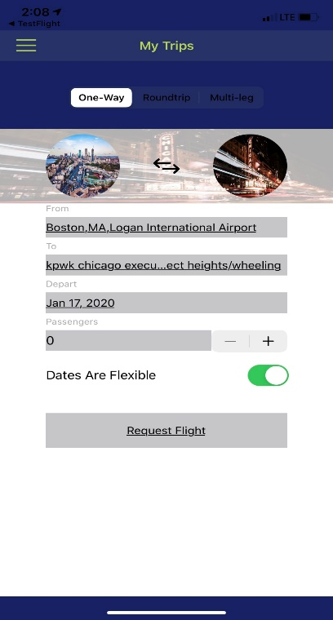

1. Lets change the grey boxes to white
2. Add Aircraft Category
3. Flip the swich to auto so that days are flexible
4. Add the Icons

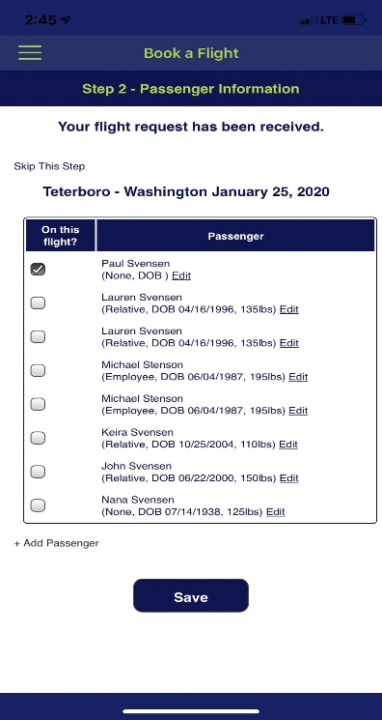 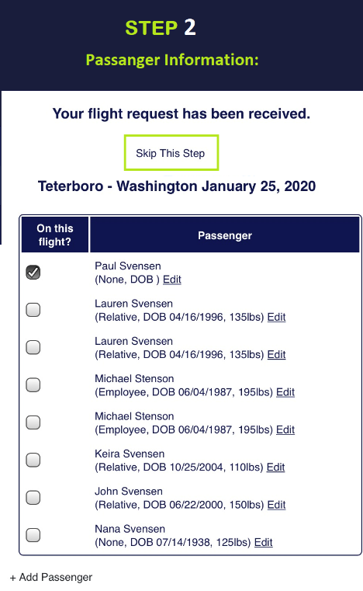



1. Make the buttons easy to Select
2. Make the + add passenger a larger button
3. Pls use the font “Working on your trip” for “step 2” and all steps

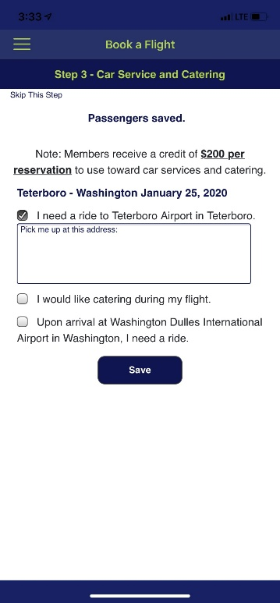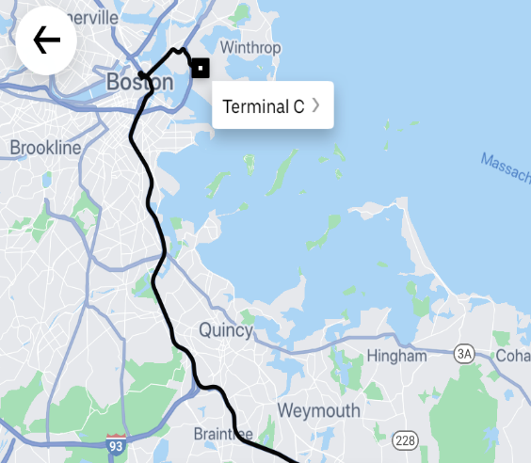

1. STEP 3
2. Easy button to click I Need a to: (airport) If clicked map will appear like Uber does with the pickup to the airport.
3. Same if the Return button is selected.
4. Use Icons
5. Lets see if we can work on the Design on this page its going to be a cool feature.

* **Confirmation Page**

**Just like this.**